## Name:______________________________

**The Discovery of the Electron**

In 1897 Joseph John (J. J) Thomson discovered the first ‘elementary particle’ – the electron.

A favourite pastime among physicists at the end of the 19th century was to amuse themselves with ‘Crookes Tubes’ (named after their inventor, Sir William Crookes). Crookes tubes were sealed glass tubes from which most of the air had been evacuated and into which electrodes (flat pieces of metal) had been inserted at each end. When a high voltage was placed between the cathode (negative electrode) and the anode (positive electrode), the tube would light up. If a metal object were inserted between the electrodes, its shadow would be cast against the anode end of the tube by the ‘cathode rays’ that were emitted by the cathode, see Figure 1. The Crookes Tube or cathode ray tube as they came to be known became the main component of the television set.

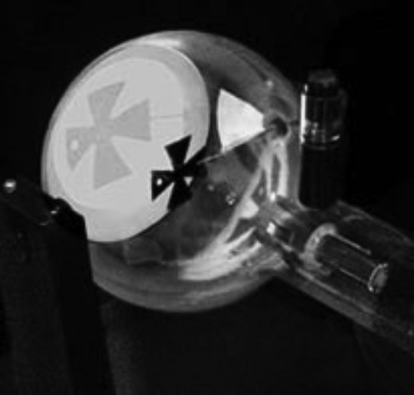

Figure 1 An illuminated Crookes Tube. The metal ‘Maltese Cross’ in the

centre of the tube is casting a shadow on the anode at the rear of the tube.

[(http://www](http://www/) outreach.phy.cam.ac.uk/camphy/electron/electron1_1.htm)

J.J Thomson noticed that these cathode rays could be deflected by both electric and magnetic fields. That meant the rays consisted of charged particles. Thomson determined that they were ‘negative corpuscles’, i.e. negatively charged particles.

Figure 1

–

An illuminated Crookes Tube. The metal ‘Maltese Cross’ in the centre o

the tube is casting a shadow on the anode at the rear of the tube. (

[http://www](http://www/)

-

outreach.phy.cam.ac.uk/camphy/electron/electron1_1.htm

)

In an ingenious experiment he measured the charge to mass ratio of this corpuscle. Because the value was not zero or infinity it meant that the particle had a definite charge and definite mass (although Thomson’s experiment could not give them individually).

Figure 3

–

Helmholtz coils surrounding a cathode ray tube.

(thesciencesource.com)

Thomson found that he could deflect the cathode rays in an electric field produced by a pair of metal plates. One of the plates was negatively charged and repelled the cathode rays, while the other was positively charged and attracted them. Thomson’s experimental setup is shown in Figure 2.

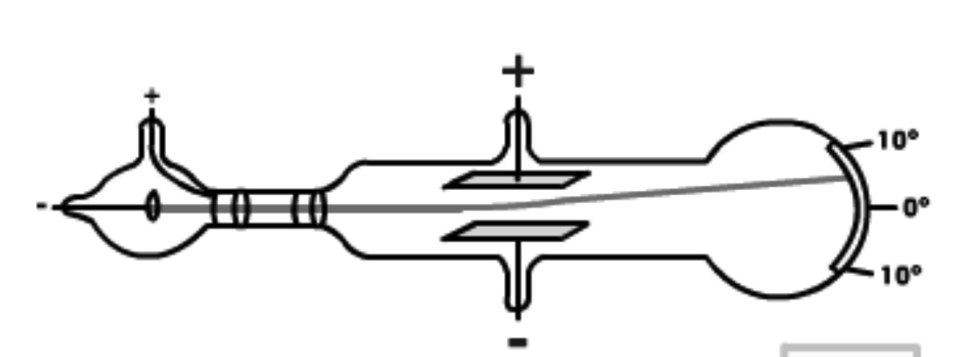

Figure 2. A beam of electrons travelling horizontally is passed through an

electric field. The electrons are attracted towards the positively charged

plate and repelled by the negatively charged plate.

[(http://www](http://www/) outreach.phy.cam.ac.uk/camphy/electron/electron1_1.htm)

Thomson was able to measure the amount of vertical deflection after the electron had passed through the plates, but he did not know what the initial speed of the electrons was.

Figure 2. A beam of electrons travelling horizontally is passed through an electri

field. The electrons are attracted towards the positively charged plate and repelle

by the negatively charged plate.

(

[http://www](http://www/)

-

outreach.phy.cam.ac.uk/camphy/electron/electron1_1.htm

)

A current in a coil of wire produces a magnetic field. Two coils arranged as a Helmholtz pair, see Figure 3, will produce a uniform magnetic field.

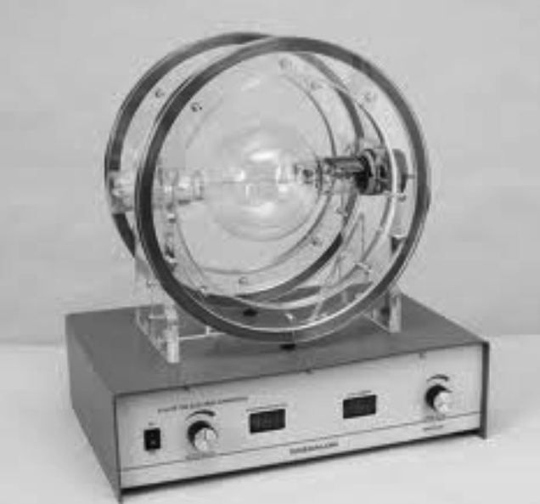

Figure 3 Helmholtz coils surrounding a cathode ray tube. (thesciencesource.com)

A beam of charged particles passing through the magnetic field will be bent at right angles to the field in a circular arc or a complete circle. In his tube, Thomson positioned the coils so that the deflection was in the opposite direction to the deflection produced by the electric field. By adjusting the strengths of the electric and magnetic fields the rays could be deflected, in one direction by the electric field and back in an equal amount by the magnetic field. The forces were balanced – this enabled Thomson to determine their initial velocity (i.e their velocity as they entered the plate region).

Answer the following questions in the spaces provided.

(36 marks)

1. Show that the velocity of an electron entering the plate region is given by

(2 marks)

1. Why do the magnetic field and electric fields need to be at right angles to each other?

(3 marks)

By turning off the magnetic field, Thomson could measure the angle of deflection of the cathode rays in the electric field alone.

1. Draw in the electric field on the diagram below and indicate the direction of the force on the electron.

(2 marks)



e-

+ + + + + + + + + + + + + + + + + + + + + + + + + +



- - - - - - - - - - - - - - - - - - - - - - - - - - - - - - - - - - - - -

1. If the plates are 8.00 mm apart and a potential difference of 2.00 kV is applied between the plates, determine the magnitude of the electric field between the plate and the magnitude of the force on the electron.

(5 marks)

1. Show that acceleration experienced by a charged particle in the field is

given by

.

(2 marks)

If the length of the plates is denoted ‘d’, and the initial (horizontal) velocity of the electrons ‘vh’ the time taken for an electron to pass through the plates will

be given by, *t*  *d*

*vh*

1. What is the vertical component of the electron’s velocity as it leaves the plate area?

(2 marks)

1. Draw a vector diagram showing the horizontal and vertical components of

the electron’s velocity and use it to show that: tan  *qEd* , where  is the

angle the electron is deflected through.

*h*

*mv*2

(3 marks)

Some typical results for Thomson’s experiment are given below: d = 0.05 m

|  |  |  |  |  |
| --- | --- | --- | --- | --- |
| E (Vm-1) | B (T) |  |  | E/v2 ( )  x 10-12 |
| 2880 | 120 | 1.6 |  | 5.00 |
| 5400 | 180 | 3.0 |  | 6.00 |
| 10080 | 312 | 5.6 |  | 9.66 |
| 16920 | 576 | 9.4 |  | 19.6 |
| 20880 | 696 | 11.6 |  | 23.2 |

1. Process the data in the table above so that you are able to plot a graph of

tan *vs E*

*v*

2

*h*

You will also need to complete the units for one column.

(2 marks)

1. Plot a graph of

tan *vs E*

*h*

*v*

2

on the graph paper on page 35.

(5 marks)

1. Determine the gradient of your graph.

(3 marks)

1. Use the gradient of your graph to determine a value for the charge to mass ratio for an electron.

(3 marks)



1. Use the values on your data sheet to determine the currently accepted charge to mass ratio for an electron.

(2 marks)

Thomson also measured the charge to mass ratio for hydrogen ions. Hydrogen ions were particles that had all the same properties as hydrogen atoms except that, while an electric field did not deflect the atoms, it deflected the ions in an opposite direction to the ‘negative corpuscles’. This meant the hydrogen ions were positively charged. Also the q/m ratio of the negative particles seemed to be about 1000 times larger than the q/m ratio of the hydrogen ion. Assuming the charges were the same, the new particle must be 1000 times lighter than hydrogen. The conclusion was that the atom was no longer the smallest entity. Thomson had discovered the first sub-atomic particle, which soon became known as the electron.

1. Discuss change in gradient for a hydrogen ion if the initial velocity is the same and the length of the plates.

(2 marks)

**END OF TEST**